Language Arts with Mrs. Rollins

About Me

This is my 12th year teaching and 7th year at Castle South.

I coach track (sprints and hurdles) and Academic Team.

I live in Warrick County with my husband, daughter, and son.

Education: University of Southern Indiana (Bachelor’s and Master’s degrees)

I was chosen this past school year to travel to Poland at the end of July to study the Holocaust. It was an amazing experience and I look forward to sharing it with my classes.

Communication

Email: srollins@warrick.k12.in.us

Phone: 812-490-7930

Sign-up for Remind texts/notifications

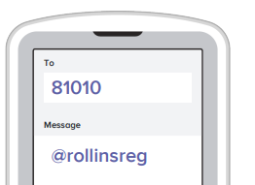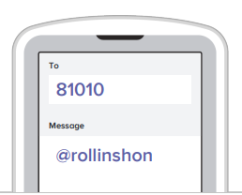

Periods 2, 3, and 4 Sign-up information

Period 8 Sign-up information

Class Website

mrsrollinsclass.weebly.com

Grade Weights

* 20% Participation and Completion
* 50% Formative Assessments (Homework, mini-quizzes)
* 30% Performance Assessments (projects, essays, etc.)

Class Overview

-We will read several novels and short stories. Non-fiction text will also be covered.

-Students can expect to study literary concepts, create small projects, deliver speeches/oral presentations, and craft essays.

-Our units will consist of the following topics:

* American Revolution
* The Horror Genre
* The Holocaust
* Dystopias
* Approaching Adulthood
* Civil War